VLPRA Soccer
Winter 7v7 Coed-Middle and high school Boys/Girls leagues
10 players per team $500 per team Nov through 2nd week Jan. Games 2x per week and End of season tournament. Teams practice on their own. All teams must have a team manager. They must be 18 years or older and are responsible for team contact and conduct at games, and will need to complete the VLPRA background check. Instructions below:
Go to www.vlpra.com: on the top center of the page choose the volunteer link.
You will choose I want to volunteer, and on the next page select youth athletic coach at the bottom of the page.
You will fill out a background information consent form, and a perspective volunteer consent form.
This will bring you to a tell us about yourself page and on the bottom please include winter 7v7 under volunteer details for youth athletics and other in the drop down menu.

November 7v7
30 | 31 | 1 |  | 2 | 3
6 | 7 | 8 |  | 9 | 19
13 | 14 | 15 |  | 16 | 17
X | X | X |  | X | X
December
27 | 28 | 29 |  | 30 | 31
4 | 5 | 6 |  | 7 | 8
11 | 12 | 13 |  | 14 | 15
January
1 | 2 | 3 | 4 |  | 5
8 | 9 | 10 | 11 7v7Tourney |  | 12 7v7Tourney
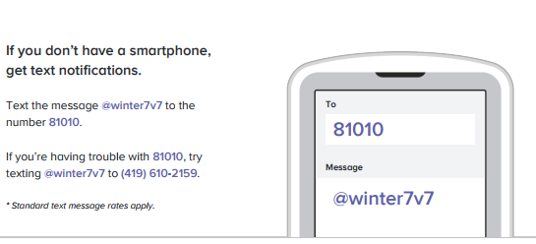
Sign up for reminders on remind 101
Use the website:
http://vlpra7v7.weebly.com/

